Lab 3: Windows Batch Script Automation for Local and Remote Repository Synchronization

Theory
Windows batch scripting is a method of automating repetitive command-line tasks in Windows through files with the .bat extension. File and folder synchronization maintains a duplicate copy of data from a source location to a destination location. The XCOPY command supports this process by copying files and directories, including subdirectories when appropriate options are used. Automating synchronization helps reduce manual effort and supports regular data backup or replication.
Windows Task Scheduler is a system utility that runs a program or script automatically at a defined time or interval. When a batch script is scheduled, the synchronization process can occur periodically without requiring user interaction. This improves reliability by ensuring that changes in the source directory are copied to the destination directory regularly.
Git is a distributed version-control system used to track changes in files and synchronize work between local and remote repositories. The basic synchronization workflow consists of modifying files locally, staging and committing the changes, and using git push to upload them to the remote repository. Conversely, git pull retrieves and integrates the latest remote changes into the local repository. This workflow is important for maintaining updated project copies and supporting collaboration.

3.1) Write a Windows Batch Script to automate the synchronization of files and folders between a source and destination directory using the XCOPY command and schedule it using Windows Task Scheduler.
Procedure:
Step 1: Open Command Prompt.
Step 2: Create two directories:
- mkdir source
- mkdir destination
Step 3: Navigate to the source directory and create sample files and folders.
Step 4: Return to the Desktop and create a batch file named replica.bat.
Step 5: Open the batch file using Notepad.
Step 6: Write the following script in the batch file:
@echo off
xcopy Source_Path Destination_Path /I /E /Y
echo Done.
Step 7: Save the batch file.
Step 8: Open Windows Task Scheduler and create a Basic Task.
Step 9: Configure the task to execute replica.bat automatically at a specified interval (e.g., every 5 minutes).
Step 10: Verify that synchronization occurs automatically.
Step 11: End the practical.

Block Diagram:
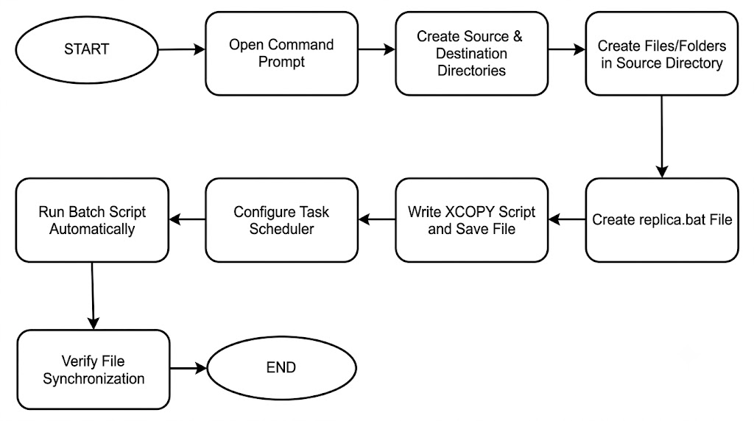

Source Code
echo @off

xcopy "D:\Prasoon Raj Shakya\BSc. CSIT\4th sem\Lab works\OS\source" "D:\Prasoon Raj Shakya\BSc. CSIT\4th sem\Lab works\OS\destination"

echo done

Screenshots
Creating directory source and destination
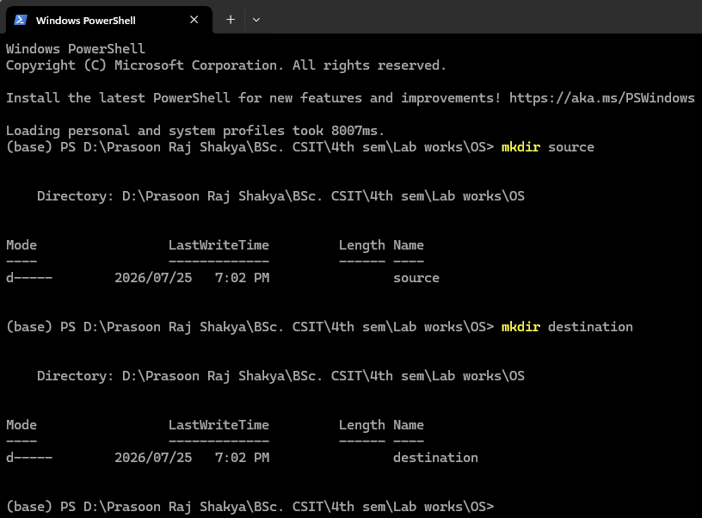
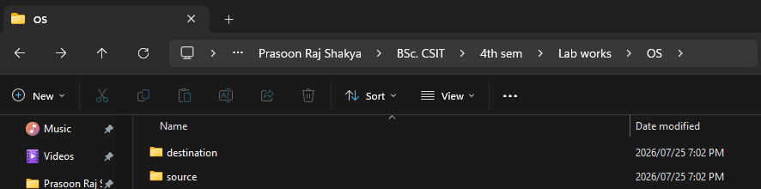
Creating file prasoon.txt in source
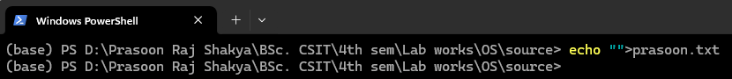
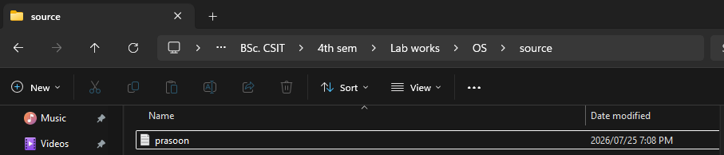
replica.bat in Notepad
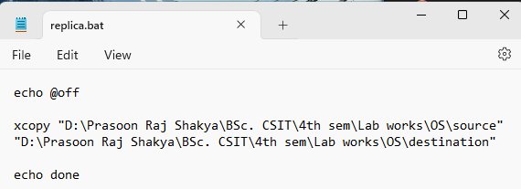
Scheduling Using task scheduler
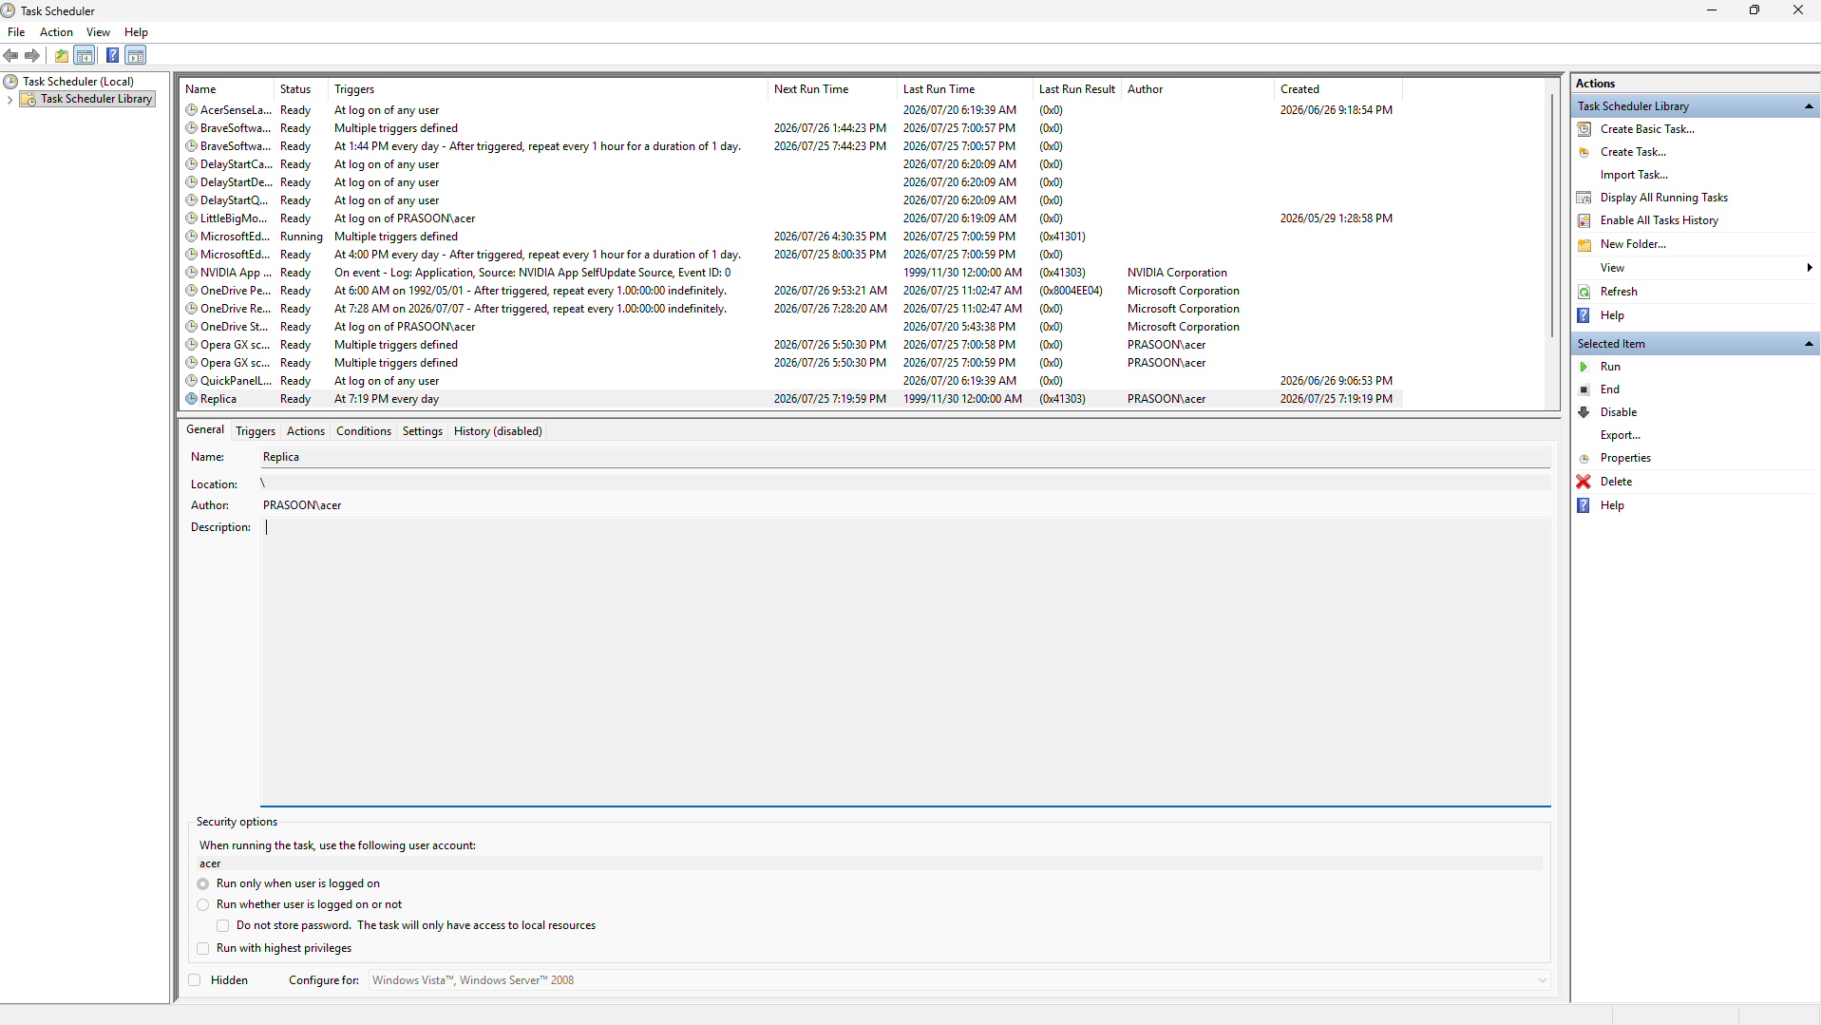
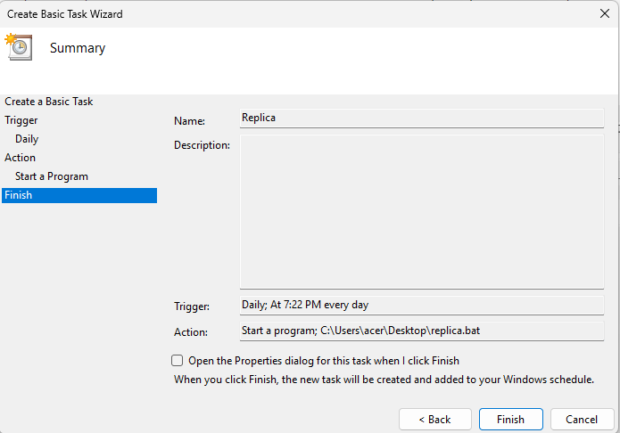
After the task scheduler executes replica.bat
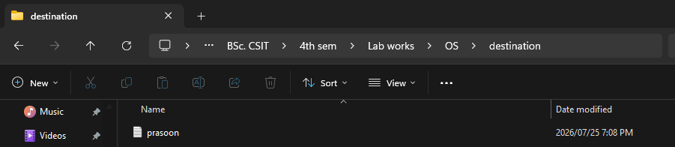

3.2) Demonstrate remote repository synchronization using Git by performing push and pull operations between a local repository and a remote repository.
Procedure:
Step 1: Open the local Git repository (agent repo) in Command Prompt.
Step 2: Make changes by creating or modifying files in the local repository.
Step 3: Stage the changes using:
git add .
Step 4: Commit the changes using:
git commit -m "Commit message"
Step 5: Push the committed changes to the remote repository using:
git push
Step 6: Verify that the changes are uploaded to the remote repository.
Step 7: Make changes in the remote repository (or from another local copy).
Step 8: Update the local repository by executing:
git pull
Step 9: Verify that the latest changes are synchronized successfully.
Step 10: End the practical.

Screenshots
Git push
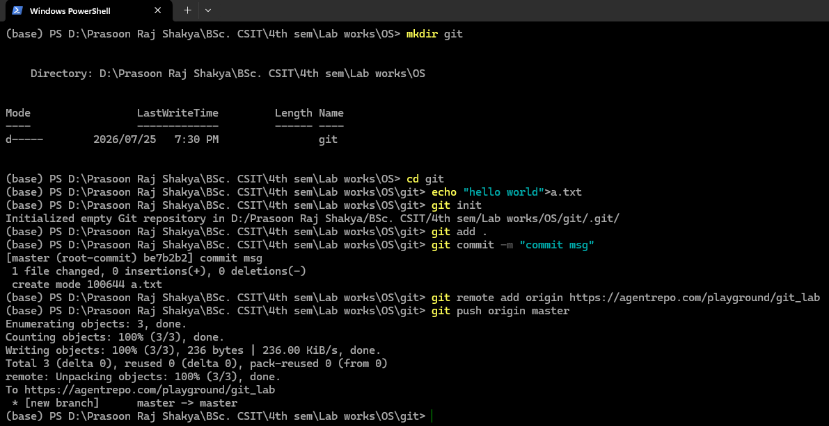
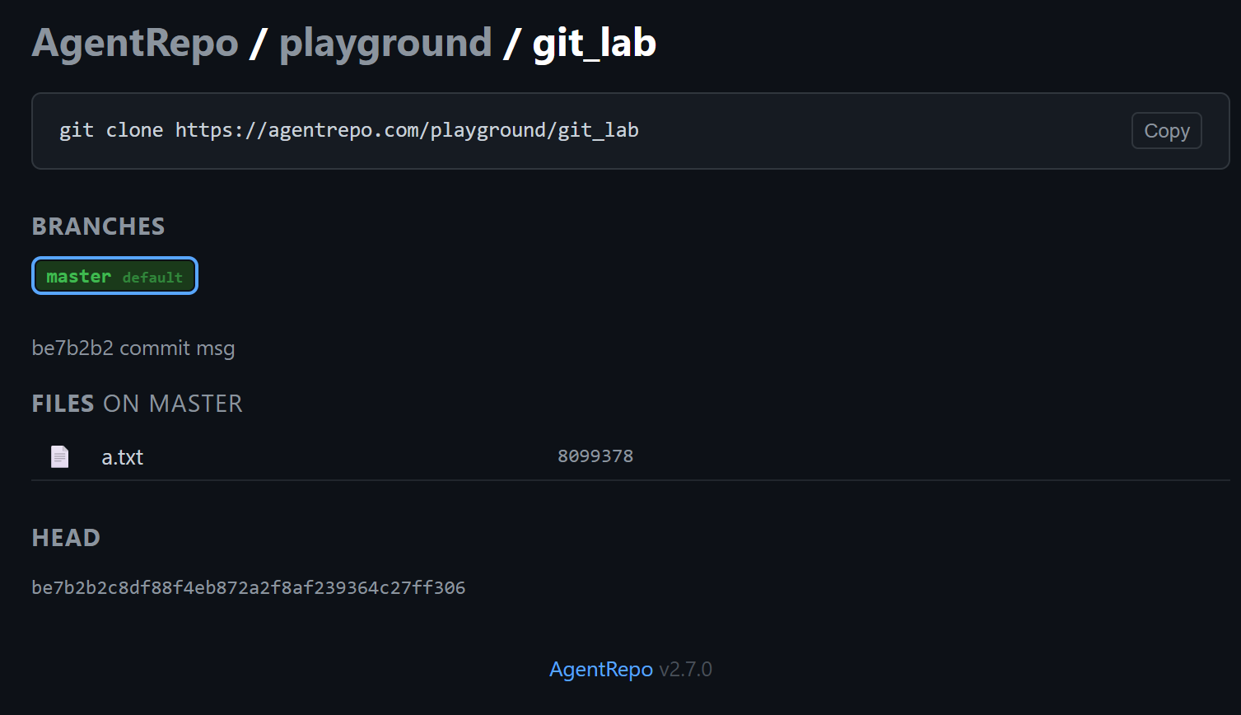
Git clone
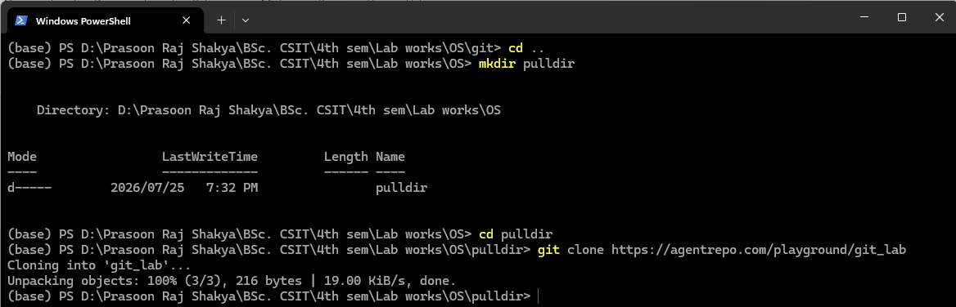
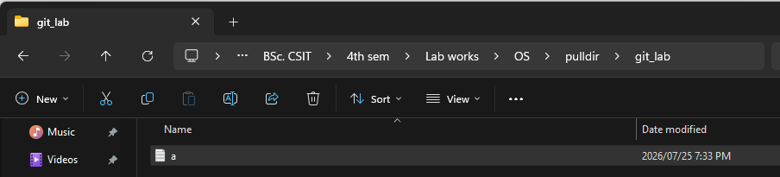
Git pull
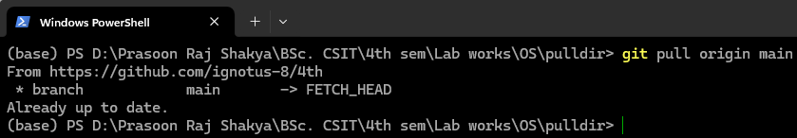

Conclusion
This experiment demonstrated automated synchronization of local files and folders using a Windows batch script, XCOPY command, and Windows Task Scheduler. It showed that scheduled execution can maintain a regularly updated copy of a source directory at a destination location. The experiment also demonstrated Git-based synchronization between local and remote repositories through push and pull operations. These activities provided practical understanding of automation, backup replication, version control, and remote repository management. Therefore, the objectives of the experiment were successfully achieved.

